Lab 6: NoSQL database models

PreLab
- [Chapter 9, Section 9.1 to 9.6] Lingras, P. (2016-01-01). Building Cross-Platform Mobile and Web Apps for Engineers and Scientists: An Active Learning Approach. [[VitalSource Bookshelf version]]. Retrieved from vbk://9781305855892
- https://www.mongodb.com/docs/manual/introduction/
- https://www.sqlitetutorial.net/wp-content/uploads/2018/03/sqlite-sample-database-diagram-color.pdf

InLab
- Install MongoDB Compass. Download here: MongoDB Compass | MongoDB. For Ubuntu 64 bit OS, Download here >> https://downloads.mongodb.com/compass/mongodb-compass_1.41.0_amd64.deb
Installation:

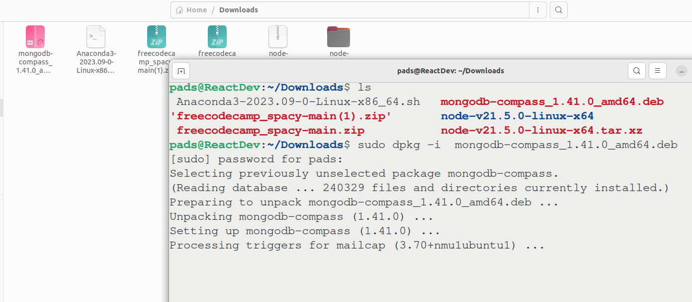
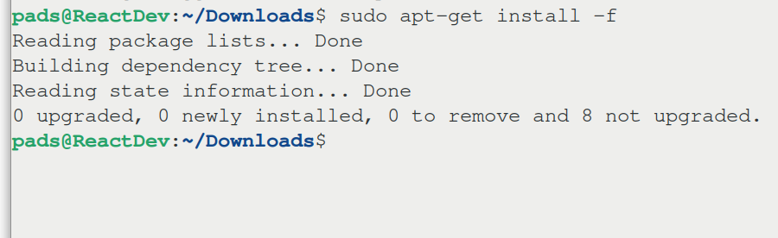
Search for mongodb
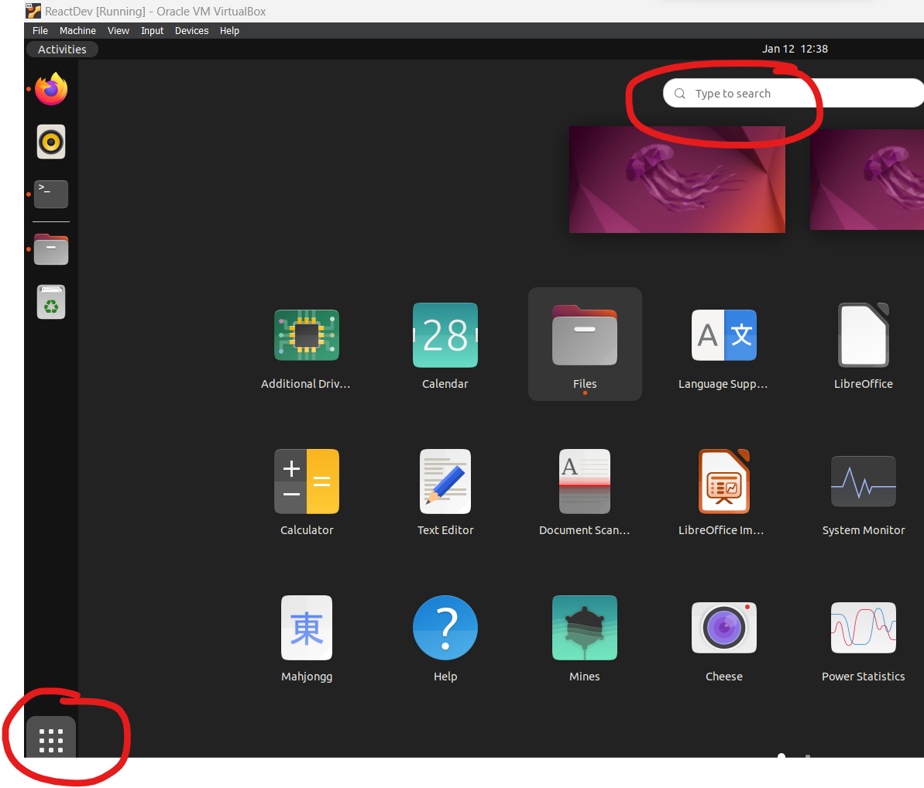
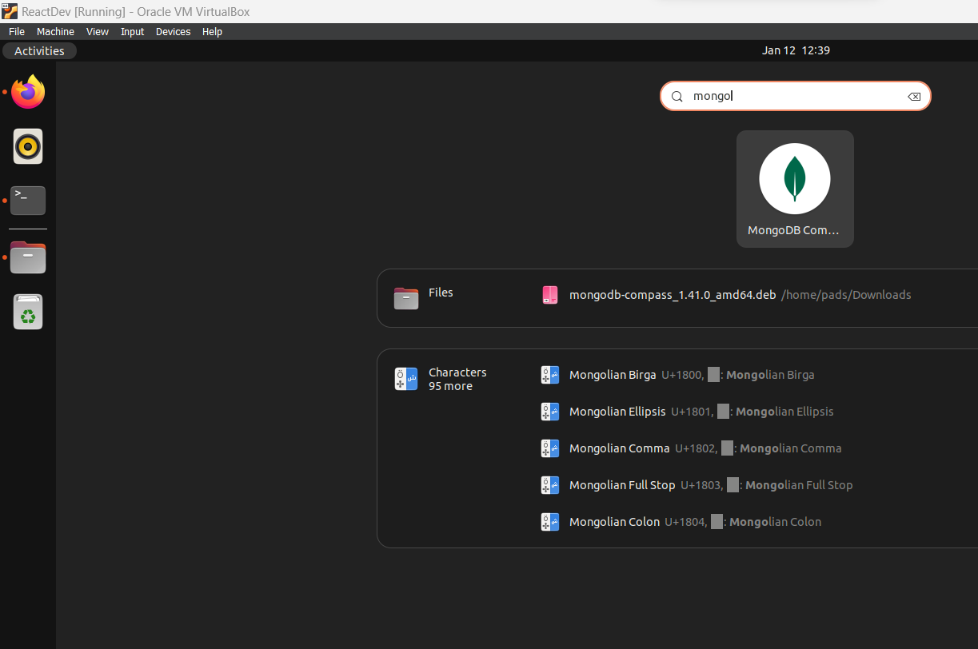
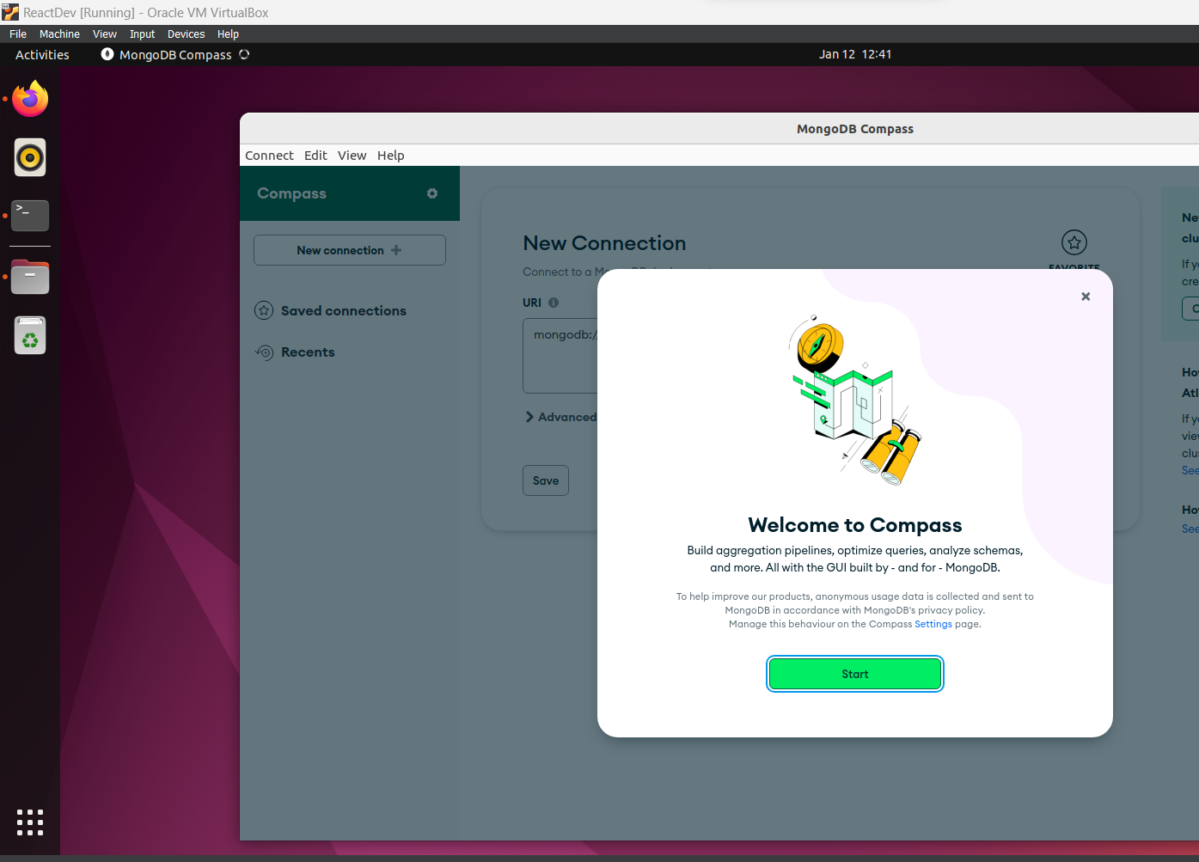
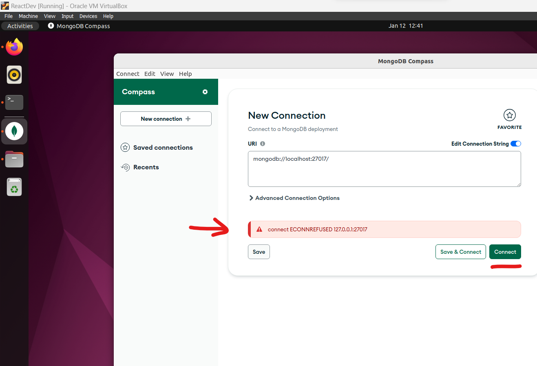
Workaround:
- Install MongoDB Community Edition >> Install MongoDB Community Edition on Ubuntu — MongoDB Manual
- Run MongoDB Community Edition >> command: sudo systemctl start mongod

Sample Python MongoDB operations

Activate softDes virtual environment | 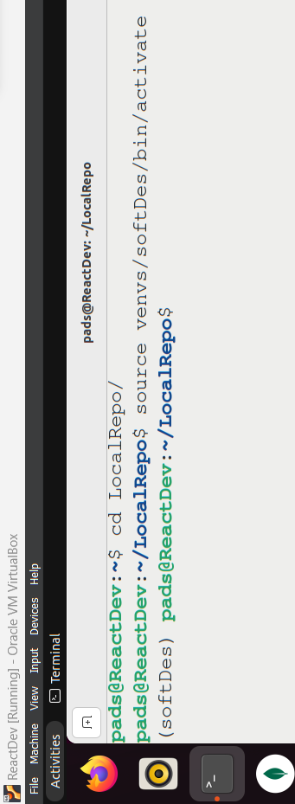
Pip install pymongo | 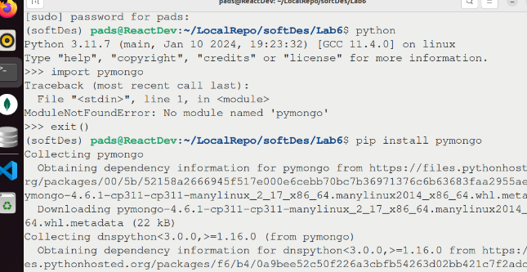
Inside the python interactive terminal, run the following commands shown in the screengrab.  Note: You need to run the mongodb process before you can connect to your mongodb database.  Command: sudo systemctl start mongod | 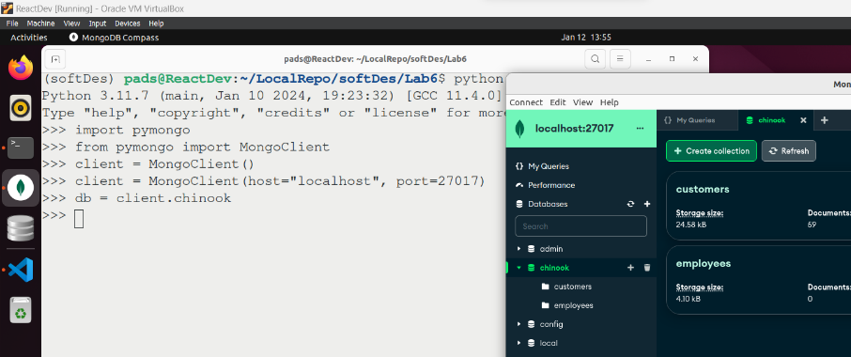
Navigate to Lab6 directory and open visual studio code | 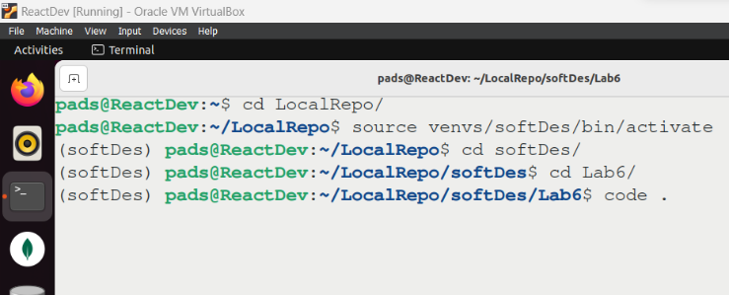
Check if you have the chinook database and the customers collections and documents. If you don’t have, open the chinook database and “export as JSON file” the customers table | 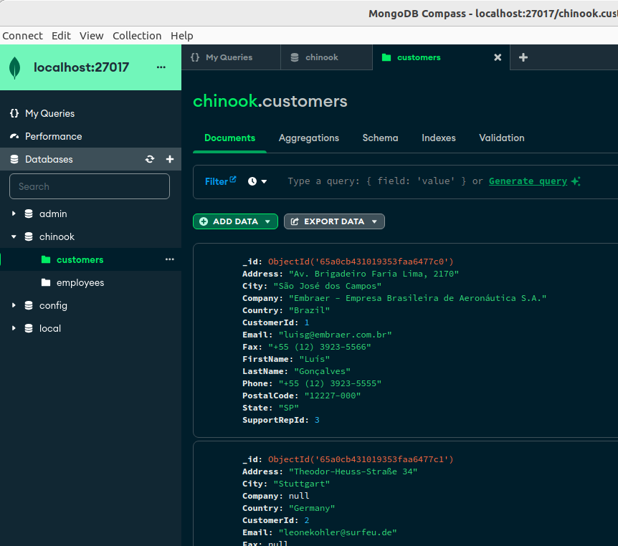
Enter the following lines in VS Code:  from pymongo import MongoClient  import pprint  import re  # client = MongoClient(host="localhost", port=27017)  client = MongoClient("mongodb://localhost:27017/")  # Get reference to 'chinook' database  db = client["chinook"]  # Get a reference to the 'customers' collection  customers_collection = db["customers"]  # print(customers_collection)  #print first document  doc1 = customers_collection.find_one()  print(doc1)  client.close() | 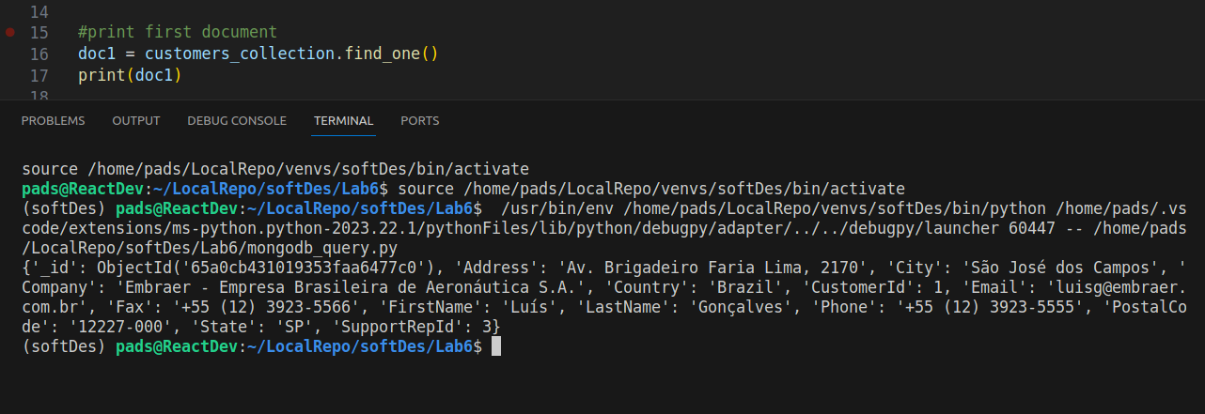\  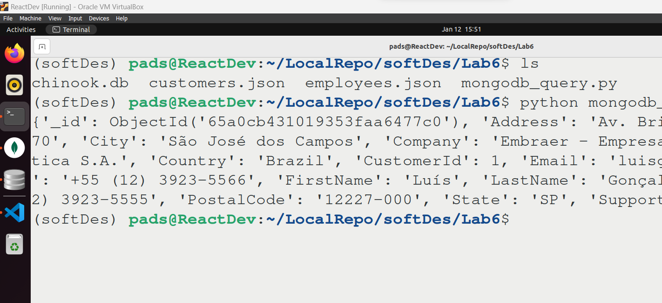
Print all documents of the customers collection  Comment this  #print first document  # doc1 = customers_collection.find_one()  # print(doc1)  And add the following line  #print all documents  for all_doc in customers_collection.find():  print(all_doc) | 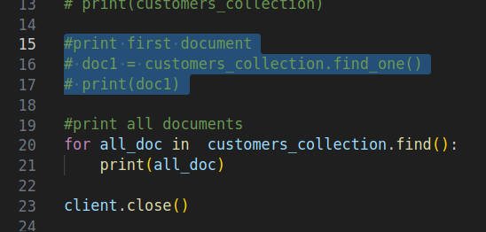  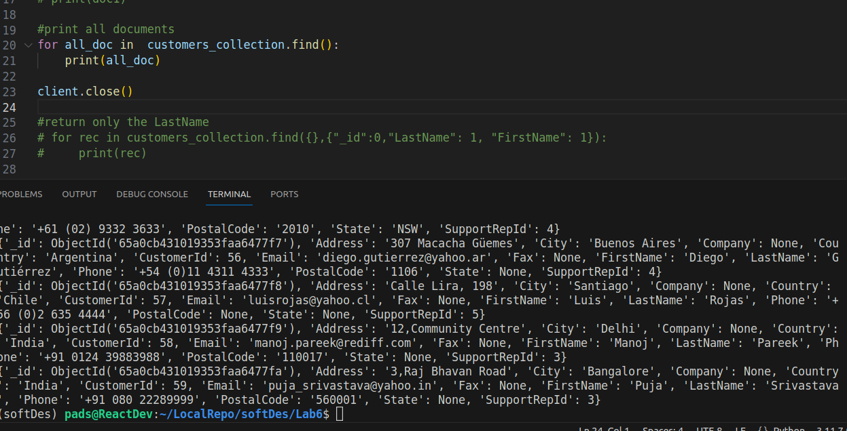
#return only the LastName and FirstName  for rec in customers_collection.find({},{"_id":0,"LastName": 1, "FirstName": 1}):  print(rec) | 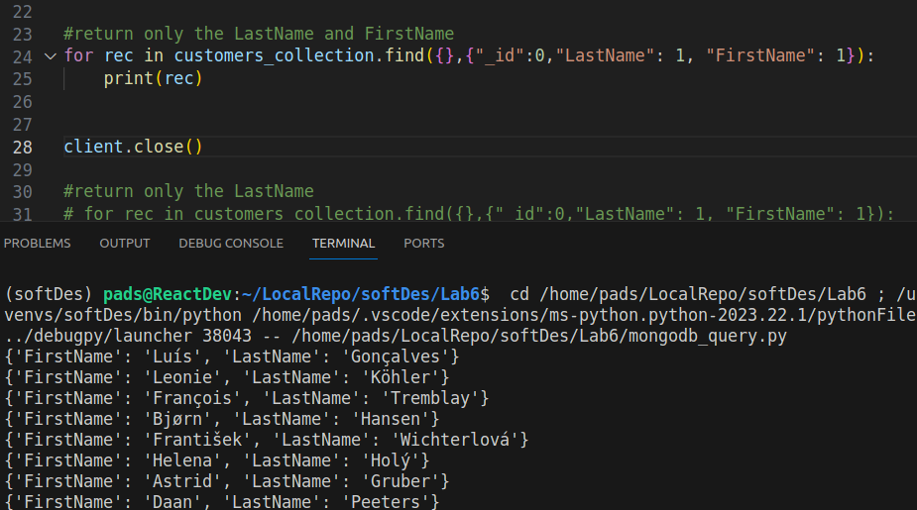
Print all customers with LastName that starts with “G”  rgx = re.compile('^G.*?$', re.IGNORECASE) # compile the regex  cursor = customers_collection.find({"LastName":rgx })  num_docs = 0  for document in cursor:  num_docs += 1  pprint.pprint(document)  print()  print("# of documents found: " + str(num_docs)) | 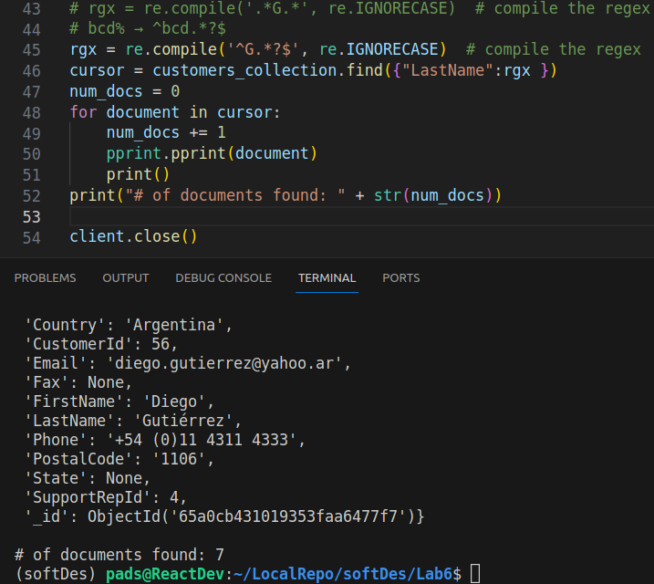
 | 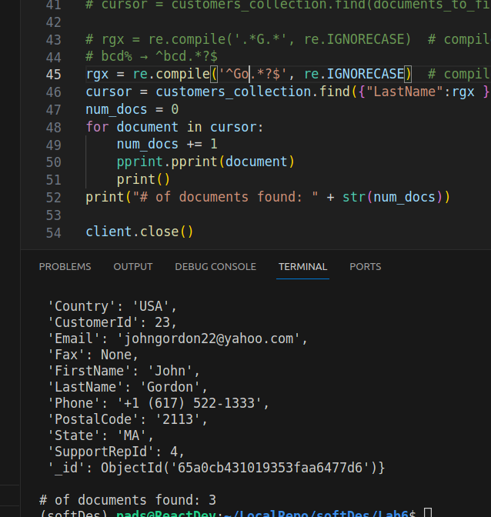
 | 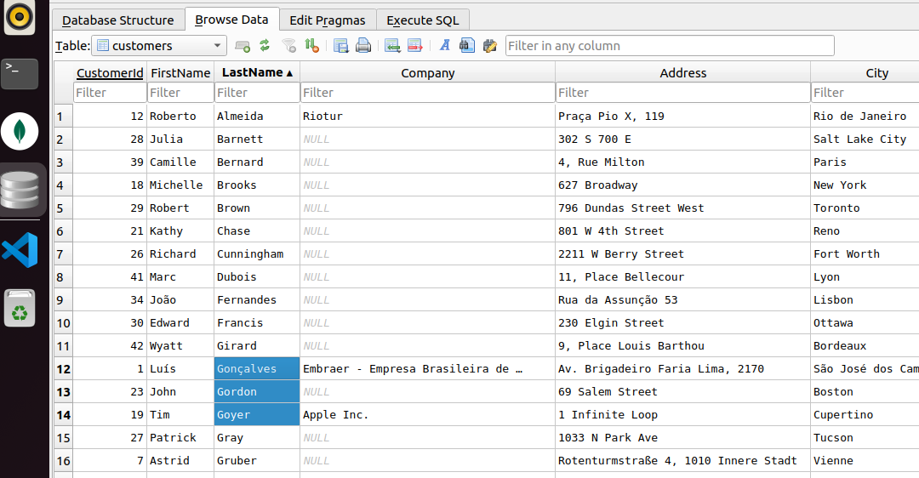

References:
- Python and MongoDB: Connecting to NoSQL Databases – Real Python
- Installation: Install MongoDB — MongoDB Manual
- https://www.mongodb.com/basics/get-started
- Perform MongoDB CRUD Operations CRUD operations: MongoDB CRUD Operations — MongoDB Manual
- MongoDB CRUD Operations in Python >> MongoDB CRUD Operations in Python - Learn | MongoDB

PostLab
Using the ERD shown here >> Chinook DB ERD , create the artists-albums-tracks database in MongoDB compass.

